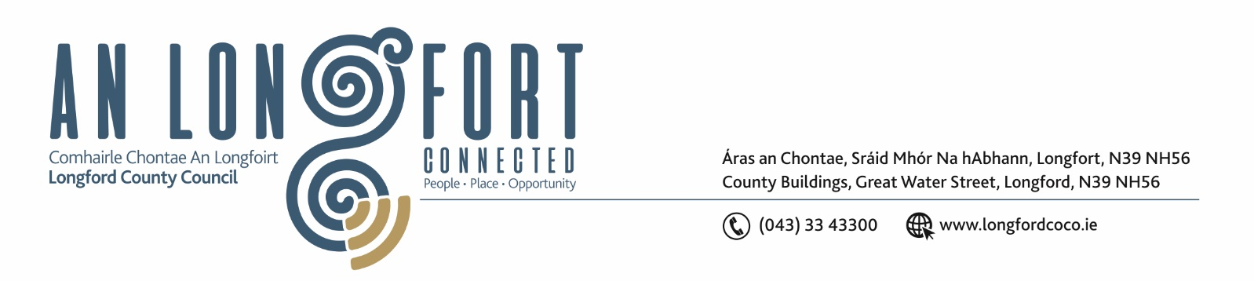

6u Mi na Nollag 2018

Chuig: Gach Ball don Chomhairle.

A Chomhairleoir,

Iarrtar ort bheith i láthair ag Cruinniú Míosuil Chomhairle Chontae Longfoirt a tionólfar i Seomra na Comhairle, Aras an Chontae, Longford ar an Chéadaoin, 12u Mi na Nollag 2018 ag 4.00 p.m chun gnó a dhéanamh d’réir an Chláir thíos.

You are requested to attend the Monthly Meeting of Longford County Council to be held in the Council Chamber, Aras an Chontae, Great Water Street, Longford on Wednesday, 12th December 2018 at
4.00 p.m. to transact business, as set out on the Agenda hereunder.

The Launch of The Garda Divisional Youth Achievement Awards will be held at 3.30 p.m.

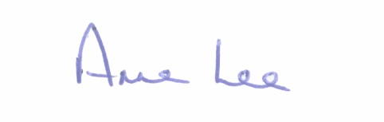
Mise le meas,

__________________
Anne Lee,
Meetings Administrator.

C L A R

- Confirmation of Minutes of the following meeting of Longford County Council –
- Monthly Meeting held on the 14th November 2018.
– copy enclosed.

- Matters arising from Minutes.

- To note Chief Executive Orders - enclosed.

4. To note Monthly Management Report - to follow.

5. To note adopted Minutes of Corporate Policy Group Meeting held on
10th October 2018 - (copy enclosed).

6. Economic and Community Development, Planning, Human Resources & Corporate Services, Cultural & Recreational Services.

- To note Planning Applications received since November meeting of the Council.

- Consideration of Adoption of Part 8 Report (Planning and Development Act 2000 (as amended) and Planning and Development Regulations 2001) (as amended) in respect of Public Realm Works at Market Square and Harbour View, Longford - details attached.

- Consideration of Adoption of Part 8 Report (Planning and Development Act 2000 (as amended) and Planning and Development Regulations 2001) (as amended) in respect of Public Realm Works at Longford Shopping Centre and Grafton Court - details attached.

- Consideration of Adoption of Part 8 Report (Planning and Development Act 2000 (as amended) and Planning and Development Regulations 2001) (as amended) in respect of
N55 Main Street, Ballymahon Improvement Works, Main Street, Ballymahon - details attached.

- Consideration of Adoption of Part 8 Report (Planning and Development Act 2000 (as amended) and Planning and Development Regulations 2001) (as amended) in respect of R392 Ballymahon Main Street Upgrade from Nallys Corner to St. Matthew’s Church on Main Street, Ballymahon - details attached.

- Consideration of Adoption of Part 8 Report (Planning and Development Act 2000 (as amended) and Planning and Development Regulations 2001) (as amended) in respect of
proposed construction of c.1.8km path linking Royal Canal Walk to Newcastle Woods- report to follow.

- Consideration of Adoption of Part 8 Report (Planning and Development Act 2000 (as amended) and Planning and Development Regulations 2001) (as amended) in respect of
proposed construction of c.1.83 km path @ Derryaroge Bog, in the townlands of Kilnacarrow & Cloonbearla, near Lanesborough, Co. Longford- report to follow.

- (i) Political Donations - Local Elections (Disclosure of Donations
and Expenditure ) Act 1999, as amended - Members of Local Authorities.

(ii) Political Donations - Local Elections (Disclosure of Donation
and Expenditure ) Act 1999, as amended - Third Parties.
(Guidelines and form(s) to be circulated )

- Notices of Motions submitted by Councillors, as listed hereunder –

Councillor Luie McEntire.

“That Longford County Council commemorates and celebrates the centenary of the founding of the First Dáil on 21st January 1919, with appropriate ceremony and events recognising the contribution of elected member, Joseph McGuinness, T.D., to the first Dáil and those who fought for the cause of Irish freedom.”

Councillor Michael Carrigy.
“I call on Longford County Council to write to all National Schools in Co. Longford to encourage them to make a point of taking their School tour regularly in Longford, to foster a love of their county from a young age and to make people aware of the amenities we have in the County.”

7. Finance & Information Systems.
(a) To note Public Liability Claims received during November 2018.

8. Housing, Infrastructure, Environment & Emergency Services.

(a) Consideration of leasing of land at Kilcommock, Kenagh, Co. Longford, comprising 0.54 ha to Kilcommock Cemetery Committee in accordance with the terms of Section 183 of the Local Government Act 2001 issued on the 28th November 2018.

(b) Housing update report.

(c) Notice of Motion submitted by Councillor Gerry Warnock.

“I am calling on Longford County Council to write to the Minister for Housing impressing on him the need to intervene with his Department Officials, to create a special dispensation for counties like Longford where the average cost of an existing housing unit is substantially lower than the build/site cost of potential new builds (built to modern standards) as defined in the Departments Financial Model for the provision of Affordable Housing Schemes. The existing guidance could potentially preclude such counties from rolling out targeted Affordable Housing Developments, linked to employment opportunities, to cater for workers on low to middle incomes. I am requesting that this motion is sent to our constituency Oireachtas Members, to AILG/LAMA and to the other Local Authorities.”

9. General

(a) Notices of Motions, submitted by Councillors, as listed hereunder –

Councillor John Browne – adjourned from November Meeting.

“I call on Longford County Council to write to the HSE and Mr. Simon Harris, T.D., Minister for Health, stating that there is a serious need to scrap the current system being used to process Medical Card Applications and issue Cards, as it is completely antiquated and not fit for purpose.”

Councillor Paul Ross – adjourned from November Meeting.

“That this Council seeks the immediate replacement by the HSE of the 2 child psychologist posts which are currently vacant in the Longford/Westmeath area.”
“That Longford County Council write to the Minister for Finance, Paschal Donohoe, to introduce an exemption in the Sugar Sweetened Drinks Tax for small artisan drinks companies producing less than 1 million litres of drinks per annum.”

Councillor Joe Flaherty.
“That this Council noting the recent CervicalCheck Scandal, calls upon the Minister for Health and An Taoiseach to acknowledge, support and respond in detail to the demands of the Standing4Women campaign. These include:
Legislation and policy on mandatory open disclosure independent of the patient safety bill; Provision of a start and end date and full disclosure on the 1800 smears yet to be audited; and a breakdown of the new packages being negotiated with laboratories carrying out smear slide analysis including mandatory site audits.”

Councillor Michael Carrigy.

“I would like to ask the Minister of Agriculture to review Part 2 of Article 50 of EU Regulation 1307/2013 and extend this provision to young farmers who set up a holding in the period 2010 – 2013.”

10. Votes of sympathy.

11. Training -
Consideration of Report from Corporate Policy Group.



